
(Disciples of Christ)
8814 Kensington Parkway, Chevy Chase, MD 10815
www.nc4disciples.org

“Love first. Love always,
and we’ll figure out the rest of it as we go along.”

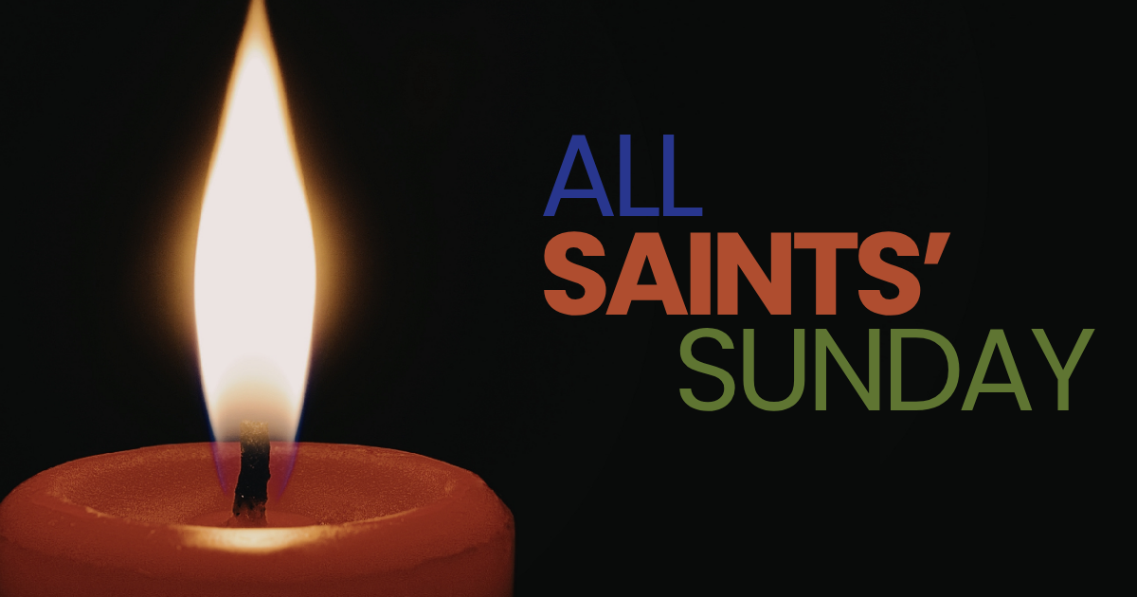

November 1st, 2025
11:00 a.m.

North Chevy Chase Christian Church is an Open and Affirming Congregation
Connecting Faith with Community.
The People of God Gather
If you’re new to North Chevy Chase Christian Church, please consider filling out the Feedback Card you will find in the Pew pocket. We’ll follow up with a brief phone call or email to say thank you for worshipping with us and to answer any question you may have.
We are glad you’re here with us today!

Welcome Rev. Stephen Tickner

Preparation for Worship & The Placing of the Saints
Glenn Pearson, Pianist/Organist
As the music is played, you are invited to come forward with a picture or relic of your loved one, place it on the table, and light a candle next to it.

Congregation standing in body or spirit
Call to Worship and Opening Prayer Cheryl Parsons
Worship Leader

One: We gather in the presence of God and in the company of the saints.

ALL: We are surrounded by a great cloud of witnesses.

One: We remember those who prophesied,
those who spoke out,
those who made their witness for God.
ALL: We remember those who gave their lives
so every voice might be heard.

One: We give thanks for neighbors and colleagues
who make their witness for God and the good of
all.

ALL: We come with gratitude for courage
and with hope for the days ahead.
Let us run with perseverance the race that is set before us,
looking to God, who is ever faithful.

One: Now with our hearts open to God, let us pray...

Opening Hymn “For All the Saints” CH637
Verses 1&5

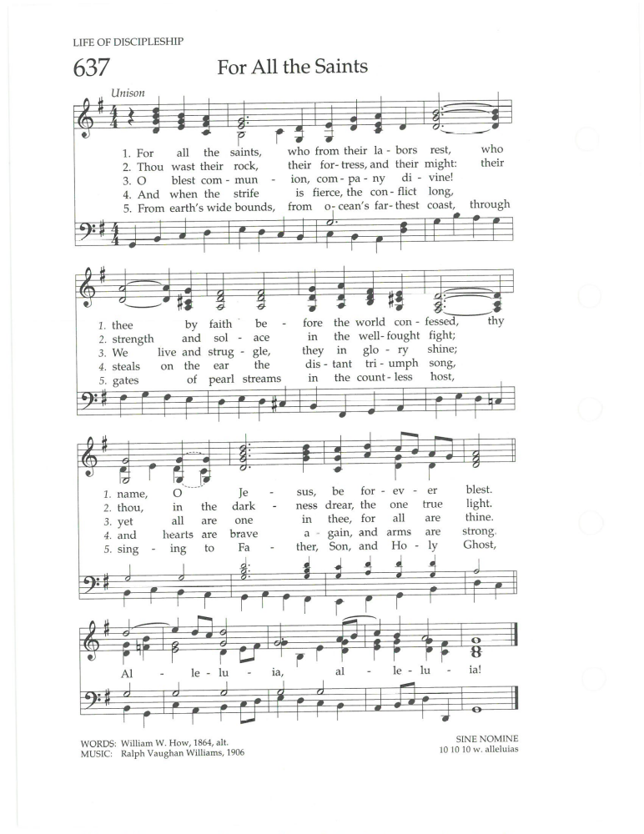

Passing of the Peace

Congregation seated
Pastoral Prayer & Prayers of the People
The Lord's Prayer
ALL: Our Father, who art in heaven, hallowed be thy name, thy kingdom come, thy will be done, on earth as it is in heaven. Give us this day our daily bread; and forgive us our debts, as we forgive our debtors; and lead us not into temptation but deliver us from evil: For thine is the kingdom, and the power, and the glory forever. Amen.

Choral Response “Lord, for Thy Tender Mercies’ Sake”
by Richard Farrant
NC4 Choir

Honoring of the Saints

Stephen: We gather this morning to celebrate the lives of persons we name as saints, and those unnumbered throngs who praise God around the Throne. Some have touched us personally and deeply, others have touched and reshaped our society and our world. But all have helped shape who we are. We celebrate these persons and their lives in all aspects of God’s creation. Let us rejoice in God’s saints, this day and every day.
Cheryl: Living God, our Guide and Guardian,
Who sits on the throne and delivers us into eternal life,
we give you thanks for the saints whose witness has shaped our lives who now rest in the shelter of your embrace.

Charlene: As we remember those saints who have died and entered into glory during the last twelve months,
we remember their witness to your love and grace with joy and gratitude.

Stephen: So, in gratitude of these saints we take a moment to name them before you. Those saints who are dear and precious to us. We name now, those of our church family that we have lost in the past year:
(tolling of the bell after each name)

Jim Heintze

Cheryl: We also remember and celebrate the lives of the Saints in each of our lives. If you would like to remember someone in your life, you are invited to stand and offer their name now.
(bell will toll following each name)
Charlene: We bless you, O Lord, for the life and love of these dear saints and rejoice for them that they have entered into the fullness of life in your presence.

Stephen: We also remember those saints who we hold in our hearts who have not been with us for some time, yet whose life and witness continue to form and shape us as your disciples. We honor them now in a time of sacred silence.
(a bell will toll at the end of the silent moment)

Cheryl: Thank you, God, for the sacrifices made by those who have gone before us. May we walk wisely in their examples of faith, dedication, worship, and love.

Charlene: We commit to continue their legacy of walking in the Way. May new generations find us worthy to be called saints in your kingdom. In the name of the Creator, the Redeemer, and the Holy Spirit, Amen.

Choral Response
"Thou knowest, Lord, the secrets of our hearts"
from the Burial Service, by Henry Purcell
NC4 Choir

Proclaim

A Reading from the Psalms Psalm 107:1-7, 33-37

¹ O give thanks to the Lord, for he is good,
for his steadfast love endures forever.
² Let the redeemed of the Lord say so,
those he redeemed from trouble
³ and gathered in from the lands,
from the east and from the west,
from the north and from the south.
⁴ Some wandered in desert wastes,
finding no way to an inhabited town;
⁵ hungry and thirsty,
their soul fainted within them.
⁶ Then they cried to the Lord in their trouble,
and he delivered them from their distress;
⁷ he led them by a straight way,
until they reached an inhabited town.
³³ He turns rivers into a desert,
springs of water into thirsty ground,
³⁴ a fruitful land into a salty waste,
because of the wickedness of its inhabitants.
³⁵ He turns a desert into pools of water,
a parched land into springs of water.
³⁶ And there he lets the hungry live,
and they establish a town to live in;
³⁷ they sow fields and plant vineyards
and get a fruitful yield.

Message Rev. Stephen Tickner

Hymn “When You Do This, Remember Me” CH 400
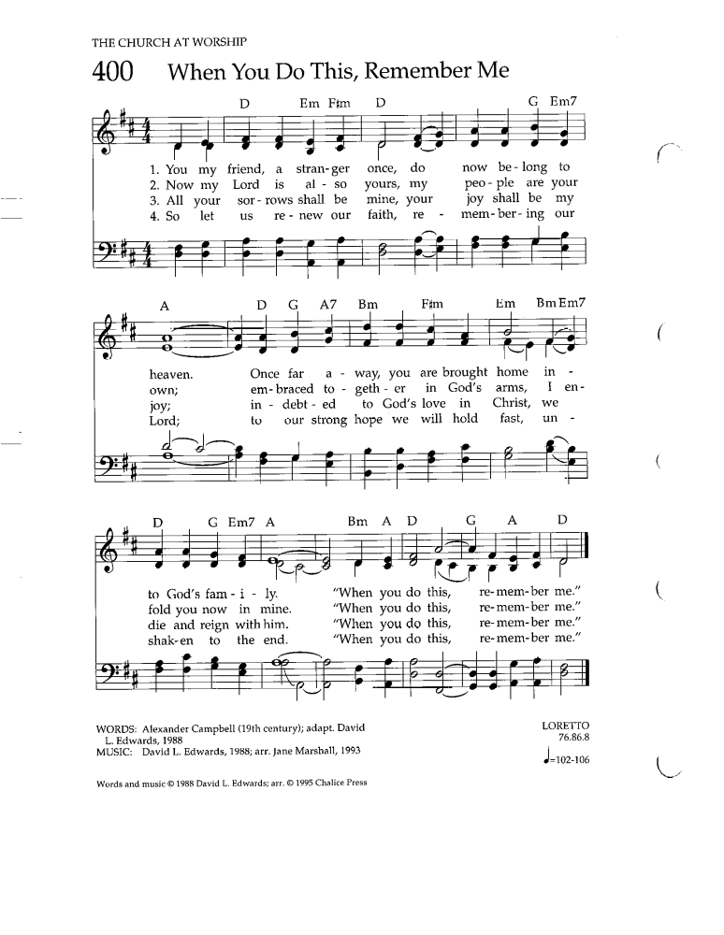

We Give and Receive
Communion is the central act of community within the Christian Church (Disciples of Christ) in remembrance of the life, death and resurrection of Christ. The invitation to the Table is extended to all who wish to follow Jesus and to share in the community of God's people. Everyone is invited to eat from this Table.

The Invitation to Give and Receive Rev. Stephen Tickner
Prayer by the Elder Sarah Casseday
Words of Institution
Coming Forward to Give, and
to Receive the Bread and the Cup
We come forward to bring our physical bodies and our financial gifts to God. You are invited to come forward down the center aisle to place your tithes & offerings in the trays available; and to receive the elements of bread and cup, taking them and returning to your seats down the side aisle, to consume the elements in silent reflection.

Communion Hymn
“Jesus, Remember Me” see screen

Music for Reflection "Love Bade Me Welcome"
from Five Mystical Songs, by Ralph Vaughan Williams
text by George Herbert
(see insert for lyrics)
Matt Amling, Soloist

Prayer of Thanksgiving

…And Go Forth to Serve

Sharing of Joys and Announcements

Congregation standing
Closing Hymn "O God, Our Help in Ages Past” CH 67
Verses 1, 4-6
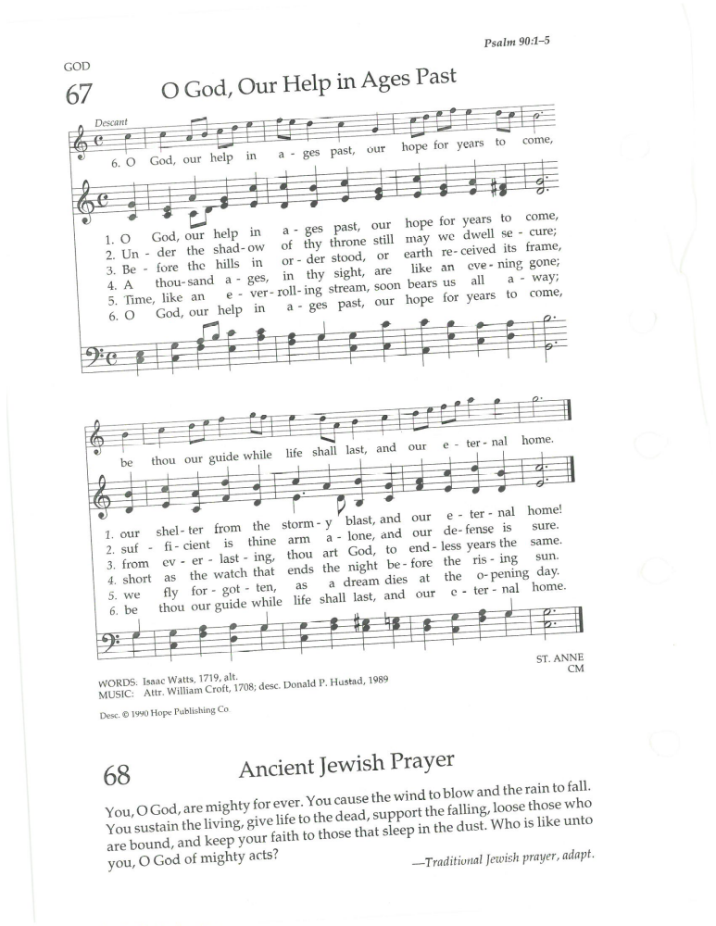

Benediction

Postlude Glenn Pearson, Pianist/Organist
~ ~ ~ ~ ~ ~ ~ ~ ~ ~ ~
Please join us for coffee hour in Harlow Hall
following the conclusion of the Postlude
~ ~ ~ ~ ~ ~ ~ ~ ~ ~ ~ ~ ~

SERVING IN WORSHIP TODAY
Rev. Stephen Tickner, Minister
Glenn Pearson, Pianist/Organist
Christine Schadeberg Wydro, Adult Choir Director
NC4 Adult Choir
Matt Amling, Guest Soloist
Cheryl Parsons, Worship Leader
Charlene Smith, Elder
Sarah Casseday, Elder at the Table
A/V Team -Yvonne McGee, Lydia Oladapo, Devi Rambarran

HEARING ASSISTANCE HEADPHONES are available in the Narthex.
Please set all pagers and cell phones to vibrate at this time.
CH = Chalice Hymnal (found in the pew racks)
Hymns today reprinted by permission under

OneLicense A-710374with podcasting #710374-A

Acknowledgment of Native Americans: A Statement toward Reconciliation
For thousands of years indigenous people have walked in this land, on their own country. Their relationship with the land is at the center of their lives. We gratefully acknowledge them, past and present, and their stewardship of this land on which we stand.

Call to Worship and Opening Prayer provided by the Center for Faith and Giving of the Christian Church (Disciples of Christ).
Quote from Chaplain Owen Chandler at the 2023 General Assembly.

